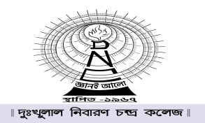

It is hereby notified that the college will remain closed tomorrow, i.e. on 30th August,2021 due to Janmastami.

Sd/- Eeshan Ali
Date:29-08-2021 Principal/ Professor in Charge

