Date: 16-06-2023

Notice
It is hereby notified that the Netaji Subhas Open University (NSOU) Study Centre will remain closed on 18-06-2023 due to Panchayat General Election Training.

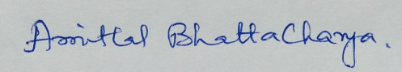
(Amitlal Bhattacharya)
Coordinator
Study Centre

